- Problem + Algorithm
Experiment No.: 08
Title: Simulated Annealing for Function Optimization
Aim:
Implement Simulated Annealing to minimize a given objective function.
Problem Statement:
Find the value of x in the interval [−10, 10] that minimizes the multimodal function f(x) = x² + 10 sin(x). The sine term creates several local minima around the parabola, so a simple descent method can get trapped. Simulated Annealing escapes local minima by occasionally accepting worse solutions with probability exp(−Δ/T), where T is the current temperature.
Algorithm:
- Initialize solution: choose a starting point x within the bounds [−10, 10] and evaluate f(x).
- Set initial temperature (T = 100), cooling rate (0.95), minimum temperature (0.001) and number of iterations per temperature (100).
- Generate neighboring solution: new_x = current_x + random value in [−1, 1], clipped to the bounds.
- Calculate change in objective function: Δ = f(new_x) − f(current_x).
- Accept/reject according to probability: accept if Δ < 0; otherwise accept with probability exp(−Δ/T).
- Reduce temperature: T = T × cooling rate, after every 100 iterations.
- Repeat until stopping criterion (T ≤ 0.001).
- Return best solution found (best_x and best_value).
- Program
Important sections of the program (q8_SA.py):
Function definition and key parameter settings
def f(x):
return x**2 + 10 * math.sin(x)

lower_bound = -10
upper_bound = 10
temperature = 100
cooling_rate = 0.95
min_temperature = 0.001
iterations = 100 # iterations per temperature level

Core algorithm
while temperature > min_temperature:
for i in range(iterations):
new_x = current_x + random.uniform(-1, 1) # neighbour
new_x = max(lower_bound, min(upper_bound, new_x))
new_value = f(new_x)
delta = new_value - current_value

if delta < 0 or random.random() < math.exp(-delta / temperature):
current_x = new_x # accept
current_value = new_value

if current_value < best_value: # track best
best_x = current_x
best_value = current_value

temperature *= cooling_rate # cooling

The complete executable program can be maintained digitally through Github.
- Output + Analysis
Objective Function:
f(x) = x² + 10 sin(x)
Search Interval:
−10 ≤ x ≤ 10
Initial Solution: x₀ = 2.7885 (random start in [−10, 10], seed 42)
Initial Temperature: T₀ = 100
Cooling Rate: 0.95
Iterations per Temperature: 100 (22,500 iterations in total until T ≤ 0.001)
Program Execution
Final Optimal Solution:
x* = -1.3064
Minimum Function Value:
f(x*) = -7.9458
Execution Status: Successfully Executed
Initial Solution : 2.7885
Initial Fitness : 11.2336
Iteration 100
Current Solution : -1.7735
Current Fitness : -6.6501
Iteration 1000
Current Solution : 5.4923
Current Fitness : 23.0551
Iteration 5000
Current Solution : 3.5969
Current Fitness : 8.5403
Iteration 10000
Current Solution : -1.4503
Current Fitness : -7.8241
Iteration 20000
Current Solution : -1.2982
Current Fitness : -7.9454
Final Solution : -1.3064
Minimum Value : -7.9458

Convergence Graph
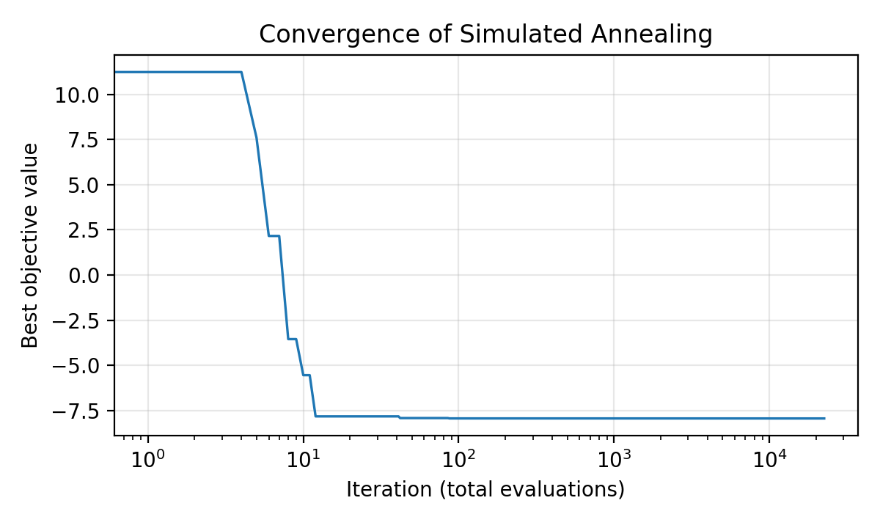
Figure: Convergence of Simulated Annealing
- X-axis → Iteration (log scale)
- Y-axis → Best objective-function value
The best-so-far value drops steeply within the first ~100 evaluations (to about −7.94) and then only fine-tunes at about −7.9458. The current solution (see the iteration log) keeps wandering while the temperature is high, accepting worse moves to explore, and settles at x ≈ −1.30 only as the temperature becomes low.
Parameter Modification
S. No. | Parameter | Original Value | Modified Value | Original Result | Modified Result | Observation
1 | Initial Temperature T0 | 100 | 50 | x = -1.3064  f(x) = -7.9458 | x = -1.3065  f(x) = -7.9458 | Lower T0 gives slightly less exploration; same minimum reached
2 | Cooling Rate α | 0.95 | 0.80 | x = -1.3064  f(x) = -7.9458 | x = -1.3062  f(x) = -7.9458 | Faster cooling uses 5,200 iterations instead of 22,500; converges sooner, with less safety against local minima
3 | Iterations per Temperature | 100 | 500 | x = -1.3064  f(x) = -7.9458 | x = -1.3064  f(x) = -7.9458 | More iterations give a more thorough search (112,500 evaluations) with no further gain here
4 | Initial Solution x0 | 2.7885 (random) | 2 | x = -1.3064  f(x) = -7.9458 | x = -1.3069  f(x) = -7.9458 | Different start gives the same global minimum; the method is insensitive to the starting point

Conclusion: Simulated Annealing located the global minimum x ≈ −1.3064, f(x) ≈ −7.9458 in every case. Results are from a run with random seed 42; values in the last decimal place can differ between runs.

- Problem + Algorithm
Experiment No.: 09
Title: Genetic Algorithm for the Travelling Salesman Problem
Aim:
Implement a Genetic Algorithm to find the shortest closed tour that visits every city exactly once.
Problem Statement:
A salesman must visit five cities, located at (0,0), (2,6), (5,3), (6,7) and (8,2), exactly once and return to the starting city. Using Euclidean distances, find the tour with the minimum total distance. A tour is encoded as a permutation of the city numbers 0–4, and its fitness is the total tour distance (smaller is better).
Algorithm:
- Initialize population: create 50 random tours (permutations of the cities).
- Evaluate fitness: compute the total distance of each tour.
- Selection: choose parents by tournament selection (3 random tours, the shortest wins).
- Crossover: apply ordered crossover – copy a segment from parent 1 and fill the remaining positions in the order of parent 2.
- Mutation: with probability 0.1, swap two randomly chosen cities.
- Elitism: copy the best tour of the previous generation unchanged into the new population.
- Replace the population with the new generation and update the best tour.
- Repeat for 200 generations (stopping criterion).
- Return the best tour and its distance.
- Program
Important sections of the program (q9_GA.py):
Function definitions and key parameter settings
cities = {0: (0, 0), 1: (2, 6), 2: (5, 3), 3: (6, 7), 4: (8, 2)}

def tour_distance(tour):
total = 0
for i in range(len(tour)):
city1 = tour[i]
city2 = tour[(i + 1) % len(tour)] # wraps back to start
total += distance(city1, city2)
return total

population_size = 50
generations = 200
mutation_rate = 0.1
tournament_size = 3

Genetic operators
def selection(population): # tournament
candidates = random.sample(population, tournament_size)
return min(candidates, key=tour_distance)

def crossover(parent1, parent2): # ordered crossover
start, end = sorted(random.sample(range(num_cities), 2))
child = [None] * num_cities
child[start:end + 1] = parent1[start:end + 1]
remaining = [c for c in parent2 if c not in child]
j = 0
for i in range(num_cities):
if child[i] is None:
child[i] = remaining[j]; j += 1
return child

def mutate(tour): # swap mutation
if random.random() < mutation_rate:
i, j = random.sample(range(num_cities), 2)
tour[i], tour[j] = tour[j], tour[i]
return tour

Core algorithm
for generation in range(generations):
new_population = [best_tour.copy()] # elitism
while len(new_population) < population_size:
parent1 = selection(population)
parent2 = selection(population)
child = mutate(crossover(parent1, parent2))
new_population.append(child)
population = new_population

current_best = min(population, key=tour_distance)
if tour_distance(current_best) < best_distance:
best_tour = current_best.copy()
best_distance = tour_distance(current_best)

The complete executable program can be maintained digitally through Github.
- Output + Analysis
Objective Function:
Minimize total tour distance: D = Σ d(city i, city i+1), including the return to the start city.
Cities (x, y):
0 (0,0), 1 (2,6), 2 (5,3), 3 (6,7), 4 (8,2)
Population Size: 50
Generations: 200
Mutation Rate: 0.1
Tournament Size: 3
Program Execution
Final Optimal Solution:
Best tour: 4 → 2 → 0 → 1 → 3 → 4
Minimum Tour Distance:
D = 24.83
Execution Status: Successfully Executed
Generation 20: Best distance = 24.83
Generation 40: Best distance = 24.83
Generation 60: Best distance = 24.83
Generation 80: Best distance = 24.83
Generation 100: Best distance = 24.83
Generation 120: Best distance = 24.83
Generation 140: Best distance = 24.83
Generation 160: Best distance = 24.83
Generation 180: Best distance = 24.83
Generation 200: Best distance = 24.83
Best tour: [4, 2, 0, 1, 3, 4]
Shortest distance found: 24.83
Brute-force check (all 12 distinct tours): 24.83

Convergence Graph
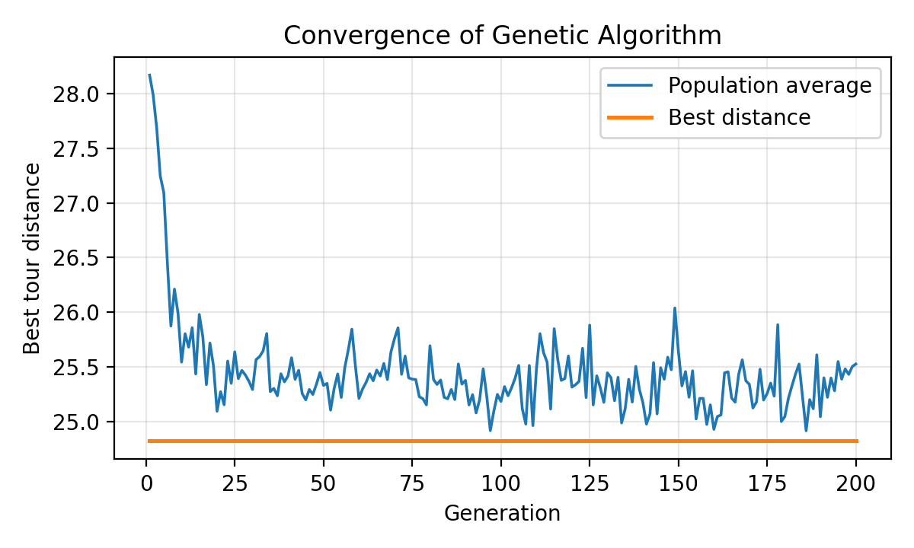
Figure: Convergence of Genetic Algorithm
- X-axis → Generation
- Y-axis → Tour distance (best and population average)
With only five cities there are just 12 distinct tours, so the best tour (24.83) was already present in the initial population and the best-distance line is flat from generation 1. The convergence is visible in the population average, which falls from about 28.2 to about 25.5 as selection and crossover fill the population with good tours.
Parameter Modification
S. No. | Parameter | Original Value | Modified Value | Original Result | Modified Result | Observation
1 | Population Size | 50 | 100 | D = 24.83 | D = 24.83 | More diversity; same optimum, higher cost per generation
2 | Generations | 200 | 50 | D = 24.83 | D = 24.83 | Optimum already found early; fewer generations suffice for 5 cities
3 | Mutation Rate | 0.1 | 0.3 | D = 24.83 | D = 24.83 | More exploration; no change for this small problem
4 | Tournament Size | 3 | 5 | D = 24.83 | D = 24.83 | Higher selection pressure; same result

Conclusion: The Genetic Algorithm found the tour 4 → 2 → 0 → 1 → 3 → 4 with distance 24.83, which matches the optimum confirmed by brute force. Parameter changes did not alter the result because the problem is very small; the effect would be visible on larger instances.

- Problem + Algorithm
Experiment No.: 10
Title: Particle Swarm Optimization for the Rosenbrock Function
Aim:
Implement Particle Swarm Optimization (PSO) to minimize the Rosenbrock function.
Problem Statement:
Minimize f(x, y) = (1 − x)² + 100(y − x²)² in the region −5 ≤ x, y ≤ 5. The function has a narrow curved valley that is easy to enter but hard to follow, with its global minimum f = 0 at (1, 1). A swarm of particles, each remembering its own best position and sharing the best position of the swarm, is used to search for this minimum.
Algorithm:
- Initialize 30 particles with random positions in [−5, 5] and random velocities in [−1, 1].
- Evaluate the fitness (Rosenbrock value) of each particle.
- Update each particle’s personal best position.
- Update the global best position of the swarm.
- Update velocity: v = w·v + c1·r1·(pbest − x) + c2·r2·(gbest − x).
- Update position: x = x + v, and clip it to the search bounds.
- Repeat for 1000 iterations (stopping criterion).
- Return the global best position and value.
- Program
Important sections of the program (q10_PSO.py):
Function definition and key parameter settings
def rosenbrock(position):
x = position[0]
y = position[1]
return (1 - x)**2 + 100 * (y - x**2)**2

num_particles = 30
dimensions = 2
iterations = 1000
w = 0.7 # inertia weight
c1 = 1.5 # cognitive coefficient
c2 = 1.5 # social coefficient
lower_bound, upper_bound = -5, 5

Core algorithm
for iteration in range(iterations):
for i in range(num_particles):
fitness = rosenbrock(positions[i])

if fitness < personal_best_values[i]: # personal best
personal_best_values[i] = fitness
personal_best_positions[i] = positions[i].copy()
if fitness < global_best_value: # global best
global_best_value = fitness
global_best_position = positions[i].copy()

r1 = np.random.random(dimensions)
r2 = np.random.random(dimensions)
velocities[i] = (w * velocities[i]
+ c1 * r1 * (personal_best_positions[i] - positions[i])
+ c2 * r2 * (global_best_position - positions[i]))

positions[i] = positions[i] + velocities[i]
positions[i] = np.clip(positions[i], lower_bound, upper_bound)

The complete executable program can be maintained digitally through Github.
- Output + Analysis
Objective Function:
f(x, y) = (1 − x)² + 100(y − x²)²
Search Interval:
−5 ≤ x ≤ 5, −5 ≤ y ≤ 5
Number of Particles: 30
Inertia Weight (w): 0.7
Cognitive / Social Coefficients (c1, c2): 1.5, 1.5
Maximum Iterations: 1000
Program Execution
Final Optimal Solution:
(x*, y*) = (1.0000, 1.0000)
Minimum Function Value:
f(x*, y*) = 0.00000000
Execution Status: Successfully Executed
Iteration 100: Best value = 0.00000158
Iteration 200: Best value = 0.00000000
Iteration 300: Best value = 0.00000000
Iteration 400: Best value = 0.00000000
Iteration 500: Best value = 0.00000000
Iteration 600: Best value = 0.00000000
Iteration 700: Best value = 0.00000000
Iteration 800: Best value = 0.00000000
Iteration 900: Best value = 0.00000000
Iteration 1000: Best value = 0.00000000
Optimization completed
Best x = 1.0
Best y = 1.0
Minimum function value = 0.0

Convergence Graph
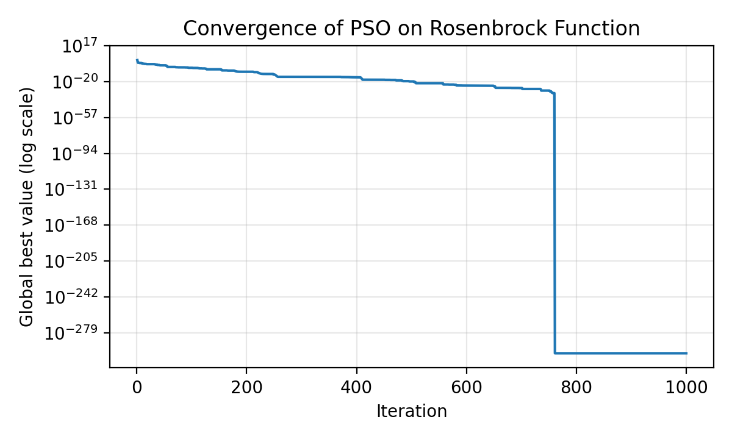
Figure: Convergence of PSO on the Rosenbrock Function
- X-axis → Iteration
- Y-axis → Global best value (logarithmic scale)
The global best value drops by many orders of magnitude (about 10⁻⁶ after 100 iterations and below 10⁻²⁵ after 600), showing that the swarm converges to the minimum at (1, 1).
Parameter Modification
S. No. | Parameter | Original Value | Modified Value | Original Result | Modified Result | Observation
1 | Inertia Weight w | 0.7 | 0.4 | f = 0  x = 1.00000  y = 1.00000 | f = 0  x = 1.00000  y = 1.00000 | Lower inertia reduces exploration; still converges
2 | c1 and c2 | 1.5 | 2.0 | f = 0  x = 1.00000  y = 1.00000 | f = 9.58e-16  x = 1.00000  y = 1.00000 | Stronger attraction; converges to within 10⁻¹⁵ of the minimum
3 | Number of Particles | 30 | 50 | f = 0  x = 1.00000  y = 1.00000 | f = 0  x = 1.00000  y = 1.00000 | More particles give better coverage; same accuracy
4 | Maximum Iterations | 1000 | 200 | f = 0  x = 1.00000  y = 1.00000 | f = 1.27e-10  x = 0.99999  y = 0.99998 | Fewer iterations leave a small error (about 10⁻¹⁰)

Conclusion: PSO reached the global minimum (1, 1) of the Rosenbrock function with an error of effectively zero within 1000 iterations. Results are from a run with random seed 42.
- Problem + Algorithm
Experiment No.: 11
Title: L1 (Lasso), L2 (Ridge) and Elastic Net Regularization
Aim:
Implement L1, L2 and Elastic Net regularization on a regression dataset and compare their effect on the learned coefficients, test error and sparsity.
Problem Statement:
A synthetic regression dataset has 200 samples and 20 features, of which only 5 are truly informative (noise = 15). Ordinary Least Squares (OLS) is compared with Ridge (L2 penalty, which shrinks all coefficients), Lasso (L1 penalty, which can set coefficients exactly to zero and so selects features) and Elastic Net (a mix of both penalties). The strength of the penalty is controlled by α; for Elastic Net l1_ratio sets the share of the L1 term.
Algorithm:
- Generate the data with make_regression: 200 samples, 20 features, 5 informative, noise 15, random seed 42.
- Split into 70% training (140) and 30% test (60) samples and standardise the features using the training data.
- Fit OLS, Ridge (α = 10), Lasso (α = 1) and Elastic Net (α = 0.3, l1_ratio = 0.5).
- Penalty added to the squared error: Ridge α·Σw², Lasso α·Σ|w|, Elastic Net a weighted mix of both.
- Evaluate each model: training R², test R², test MSE and number of coefficients equal to zero.
- Plot the learned coefficients of all models against the true coefficients.
- Compute the regularization paths (coefficients vs α) of Lasso and Ridge for 60 values of α from 0.01 to about 316.
- Plot test MSE and number of non-zero coefficients against α for Ridge, Lasso and Elastic Net.
- Program
Important sections of the program (q11_regularization.py):
Data and model settings
X, y, true_coef = make_regression(n_samples=200, n_features=20,
n_informative=5, noise=15, coef=True, random_state=42)
X_train, X_test, y_train, y_test = train_test_split(
X, y, test_size=0.3, random_state=42)
scaler = StandardScaler().fit(X_train)

models = {
"OLS (no reg.)": LinearRegression(),
"Ridge (L2)": Ridge(alpha=10.0),
"Lasso (L1)": Lasso(alpha=1.0),
"Elastic Net (L1+L2)": ElasticNet(alpha=0.3, l1_ratio=0.5),
}

Core algorithm
for name, m in models.items():
m.fit(X_train, y_train)
coefs[name] = m.coef_
# train R2, test R2, test MSE, zero coefficients printed here

alphas = np.logspace(-2, 2.5, 60)
# regularization path of Lasso
path = np.array([Lasso(alpha=a).fit(X_train, y_train).coef_
for a in alphas])

for a in alphas: # test error and sparsity vs alpha
m = cls(alpha=a, **kw).fit(X_train, y_train)
mse.append(mean_squared_error(y_test, m.predict(X_test)))
nz.append(np.sum(np.abs(m.coef_) > 1e-6))

The complete executable program can be maintained digitally through Github.
- Output + Analysis
Objective Function:
Minimise squared error + penalty (Ridge: α·Σw², Lasso: α·Σ|w|, Elastic Net: mix of both).
Dataset: 200 samples (140 train / 60 test), 20 features, 5 informative, noise = 15
Penalty Settings: Ridge α = 10; Lasso α = 1; Elastic Net α = 0.3, l1_ratio = 0.5
Random Seed: 42
Program Execution
Final Optimal Solution:
Lasso (L1, α = 1) gave the best test performance: test R² = 0.992
Minimum Test MSE:
159.8 (11 of 20 coefficients set to zero)
Execution Status: Successfully Executed
OLS (no reg.) : Train R2 = 0.991, Test R2 = 0.991, Test MSE = 166.0, Zero coefs = 0
Ridge (L2) : Train R2 = 0.987, Test R2 = 0.988, Test MSE = 231.8, Zero coefs = 0
Lasso (L1) : Train R2 = 0.990, Test R2 = 0.992, Test MSE = 159.8, Zero coefs = 11
Elastic Net (L1+L2) : Train R2 = 0.975, Test R2 = 0.975, Test MSE = 480.8, Zero coefs = 1

Result Graphs
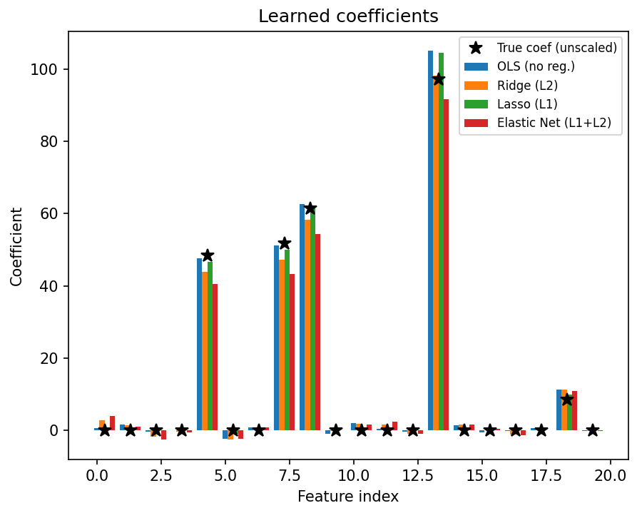
Figure: Learned Coefficients of OLS, Ridge, Lasso and Elastic Net
- X-axis → Feature index (0–19)
- Y-axis → Coefficient value (black stars = true coefficients)
Only features 4, 7, 8, 13 and 18 are informative, and all four models recover these five large coefficients. Lasso (α = 1) keeps all five and sets 11 of the 20 coefficients exactly to zero (it still keeps four irrelevant features with small values). Ridge and OLS leave all 20 coefficients non-zero, and Elastic Net shrinks the largest coefficient more (about 92 against 105 for OLS).
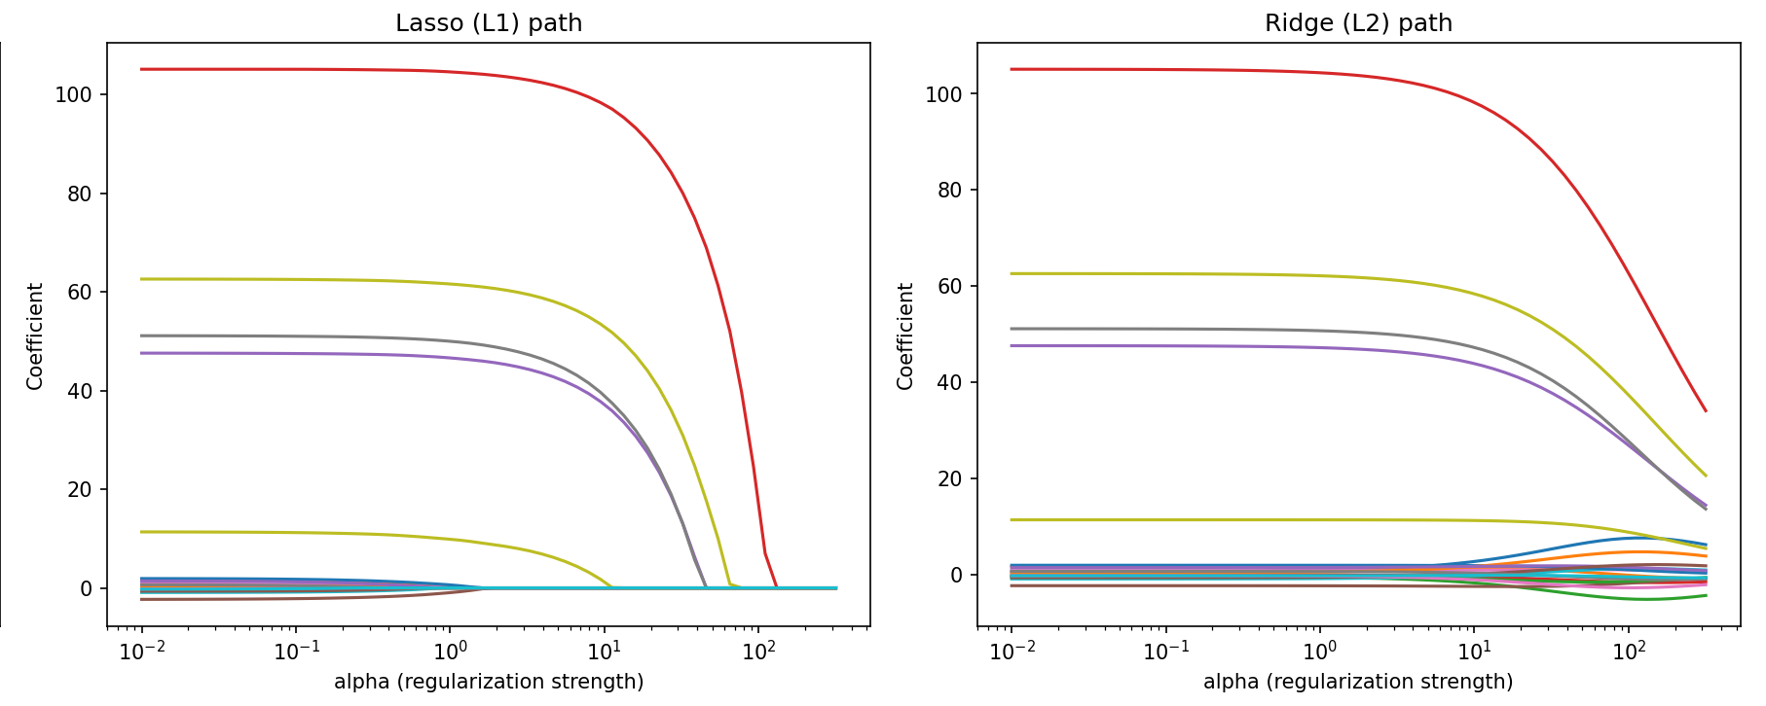
Figure: Regularization Paths of Lasso (L1) and Ridge (L2)
- X-axis → α (regularization strength, log scale)
- Y-axis → Coefficient value
In the Lasso path the coefficients drop to exactly zero one by one as α grows. The irrelevant features vanish first, and at α = 10 only the five informative features remain; all coefficients are zero by about α = 130. In the Ridge path every coefficient shrinks smoothly towards zero but none becomes exactly zero, even at α ≈ 316.
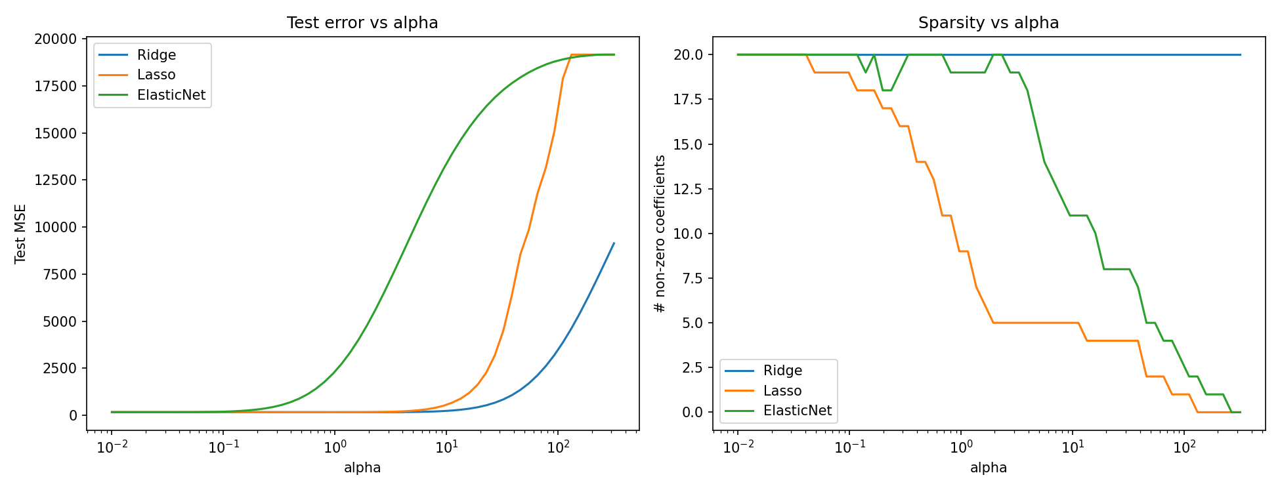
Figure: Test Error and Sparsity against α
- X-axis → α (log scale)
- Y-axis → Test MSE (left) and number of non-zero coefficients (right)
Test MSE is lowest for a small α (Ridge 162.0 at α ≈ 1.9, Lasso 159.2 at α ≈ 0.68, Elastic Net 161.7 at α ≈ 0.03) and rises sharply once α is too large and the models underfit. On the right, Lasso and Elastic Net lose non-zero coefficients as α increases (Lasso reaches 0 at about α = 130, Elastic Net later at about 265 because only half of its penalty is L1), while Ridge keeps all 20.
Parameter Modification
S. No. | Parameter | Original Value | Modified Value | Original Result | Modified Result | Observation
1 | Ridge α | 10 | 100 | Test R² = 0.988  Test MSE = 231.8 | Test R² = 0.815  Test MSE = 3488.5 | Too much shrinkage underfits; still no coefficient becomes zero
2 | Lasso α | 1 | 10 | Test R² = 0.992  Test MSE = 159.8  Zero coefs = 11 | Test R² = 0.970  Test MSE = 557.6  Zero coefs = 15 | Exactly the 5 informative features remain, but their coefficients are shrunk, so the error rises
3 | Elastic Net l1_ratio | 0.5 | 0.9 | Test R² = 0.975  Test MSE = 480.8  Zero coefs = 1 | Test R² = 0.991  Test MSE = 165.5  Zero coefs = 3 | Larger L1 share means less L2 shrinkage of the large coefficients, so error falls and more coefficients become zero

Conclusion: Lasso gave the lowest test error (MSE 159.8) and removed 11 of the 20 features, Ridge shrank the coefficients without removing any, and Elastic Net lies in between, with its result depending on α and l1_ratio. With only 5 informative features, low noise and 140 training samples, OLS is already close (MSE 166.0), so regularization gives a small accuracy gain here; its main benefit is feature selection (Lasso). Results are from a run with random seed 42.
- Problem + Algorithm
Experiment No.: 12
Title: Kernel PCA on Nonlinear Data
Aim:
Apply Kernel PCA to nonlinear datasets and visualise the class separation obtained, in comparison with linear PCA.
Problem Statement:
Two datasets of 400 points each are used: concentric circles (factor 0.3, noise 0.05) and two moons (noise 0.07). In both, the two classes cannot be separated by a straight line, and linear PCA only rotates the data, so it cannot separate them. Kernel PCA performs PCA in an implicit feature space defined by a kernel k(x, y), for example the RBF kernel exp(−γ‖x − y‖²) or the polynomial kernel (γ·x·y + c)^d, which can unfold the nonlinear structure. Separation is measured by the accuracy of a logistic regression classifier trained on the first one or two components.
Algorithm:
- Generate the two datasets with make_circles and make_moons (400 points each, random seed 0).
- Apply linear PCA with 2 components to each dataset.
- Apply Kernel PCA with 2 components using the RBF kernel (γ = 10) and the polynomial kernel (degree 3, γ = 1, coef0 = 1).
- Kernel PCA computes the kernel matrix K, centres it, finds its largest eigenvectors and projects the points onto them.
- Plot the original data and the three projections for each dataset, coloured by class.
- Fit a logistic regression on the first 1 and 2 components of the circles dataset and report the accuracy.
- Compare the accuracy of linear PCA with RBF Kernel PCA.
- Program
Important sections of the program (q12_kernel_pca.py):
Datasets and projections
datasets = {
"Concentric circles": make_circles(n_samples=400, factor=0.3,
noise=0.05, random_state=0),
"Two moons": make_moons(n_samples=400, noise=0.07, random_state=0),
}

projections = {
"Original data": X,
"Linear PCA": PCA(n_components=2).fit_transform(X),
"Kernel PCA (RBF, gamma=10)": KernelPCA(n_components=2,
kernel="rbf", gamma=10).fit_transform(X),
"Kernel PCA (poly, deg=3)": KernelPCA(n_components=2,
kernel="poly", degree=3, gamma=1, coef0=1).fit_transform(X),
}

Core algorithm (measuring class separation)
X, y = datasets["Concentric circles"]
for k in (1, 2):
for label, Z in [("Linear PCA", PCA(n_components=k).fit_transform(X)),
("RBF Kernel PCA", KernelPCA(n_components=k,
kernel="rbf", gamma=10).fit_transform(X))]:
acc = LogisticRegression().fit(Z, y).score(Z, y)
print(label, k, "component(s): accuracy", round(acc, 3))

The complete executable program can be maintained digitally through Github.
- Output + Analysis
Objective Function:
Project the data so that the two classes become linearly separable.
Datasets: Concentric circles and two moons, 400 points each
Kernels: Linear PCA; RBF (γ = 10); polynomial (degree 3, γ = 1, coef0 = 1)
Components: 2 (1 and 2 for the accuracy test)
Random Seed: 0
Program Execution
Final Optimal Solution:
RBF Kernel PCA (γ = 10) with 2 components separates the circles completely
Maximum Accuracy:
1.000 (linear PCA: 0.500)
Execution Status: Successfully Executed
Linear PCA -> accuracy using 1 component(s) (circles): 0.495
RBF Kernel PCA -> accuracy using 1 component(s) (circles): 0.755
Linear PCA -> accuracy using 2 component(s) (circles): 0.500
RBF Kernel PCA -> accuracy using 2 component(s) (circles): 1.000

Projection Plots
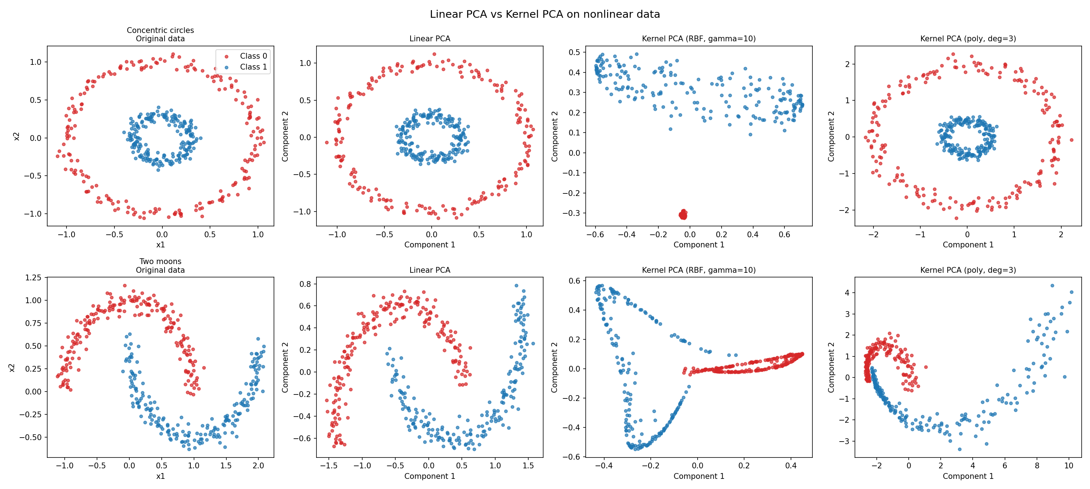
Figure: Linear PCA vs Kernel PCA on Nonlinear Data
- Rows → concentric circles (top) and two moons (bottom); columns → original data, linear PCA, RBF Kernel PCA, polynomial Kernel PCA
- X-axis / Y-axis → Component 1 / Component 2 (x1 / x2 for the original data)
Linear PCA only rotates the data, so the rings of the circles stay nested and the moons stay intertwined (accuracy 0.50 on the circles even with 2 components). With the RBF kernel (γ = 10) the outer ring of the circles collapses into a compact cluster that lies away from the inner ring along Component 2, and the two classes become perfectly separable with two components (accuracy 1.000); the first component alone gives 0.755. For the moons the RBF projection pulls the two classes into two separate arms. The degree-3 polynomial kernel leaves the circles nested and unfolds the moons only partly.
Parameter Modification
S. No. | Parameter | Original Value | Modified Value | Original Result | Modified Result | Observation
1 | RBF γ | 10 | 1 | 1 component  Accuracy = 0.755 | 1 component  Accuracy = 0.510 | Small γ makes the kernel too smooth, so the first component barely separates the rings
2 | RBF γ | 10 | 50 | 1 component  Accuracy = 0.755 | 1 component  Accuracy = 0.740 | Similar result for γ = 10 and 50; accuracy depends on γ mainly when it is too small
3 | Polynomial degree | 3 | 2 | 1 component  Accuracy = 0.490 | 1 component  Accuracy = 0.497 | The polynomial kernel with these settings does not separate the rings with one component

Conclusion: Linear PCA cannot separate nonlinear classes (accuracy 0.50 on the circles), whereas RBF Kernel PCA with γ = 10 makes the circles linearly separable (accuracy 1.000 with two components and 0.755 with only the first). The choice of kernel and its parameters matters: the polynomial kernel and a small γ gave little improvement. Accuracy is measured on the training data because the aim is to test separability, not generalisation. Results are from a run with random seed 0.
- Problem + Algorithm
Experiment No.: 13
Title: Ant Colony Optimization for Shortest Path Finding
Aim:
Implement Ant Colony Optimization (ACO) to find the shortest path between two nodes of a weighted graph.
Problem Statement:
A graph has five nodes (numbered 1–5 in the output) joined by weighted edges: 1–2 (2), 1–3 (4), 2–3 (1), 2–4 (7), 3–4 (3), 3–5 (5) and 4–5 (2). Find the shortest path from node 1 to node 5. Artificial ants build paths probabilistically using pheromone and distance information, and the pheromone is reinforced on short paths.
Algorithm:
- Initialize the pheromone matrix to 1 and compute heuristic information η = 1/distance for every edge.
- Place each of the 10 ants at the start node.
- Each ant moves to an unvisited neighbouring node with probability proportional to τ^α · η^β until it reaches the end node.
- Compute the length of every path that reached the end node and update the best path found.
- Evaporate pheromone: τ = (1 − ρ)·τ.
- Deposit pheromone on every edge of each successful path: Δτ = Q / path length.
- Repeat for 100 iterations (stopping criterion).
- Return the best path and its distance.
- Program
Important sections of the program (q13_ACO.py):
Graph and key parameter settings
graph = np.array([
[0, 2, 4, 0, 0], # 0 means no direct connection
[2, 0, 1, 7, 0],
[4, 1, 0, 3, 5],
[0, 7, 3, 0, 2],
[0, 0, 5, 2, 0]])
start, end = 0, 4

num_ants = 10
iterations = 100
alpha = 1 # pheromone importance
beta = 2 # distance importance
evaporation = 0.5
Q = 100

pheromone = np.ones((n, n))
heuristic[i][j] = 1 / graph[i][j] # for every existing edge

Core algorithm
for iteration in range(iterations):
for ant in range(num_ants):
path = [start]; visited = {start}; current = start
while current != end:
neighbors = [j for j in range(n)
if graph[current][j] > 0 and j not in visited]
if not neighbors:
break
probabilities = [(pheromone[current][j] ** alpha) *
(heuristic[current][j] ** beta)
for j in neighbors]
total = sum(probabilities)
probabilities = [p / total for p in probabilities]
next_node = random.choices(neighbors,
weights=probabilities, k=1)[0]
path.append(next_node); visited.add(next_node)
current = next_node
# (path length computed and best path updated here)

pheromone *= (1 - evaporation) # evaporation
for path, distance in zip(paths, distances): # deposit
for i in range(len(path) - 1):
a, b = path[i], path[i + 1]
pheromone[a][b] += Q / distance
pheromone[b][a] += Q / distance

The complete executable program can be maintained digitally through Github.
- Output + Analysis
Objective Function:
Minimize the total path length from node 1 to node 5.
Start / End Node:
Node 1 (index 0) → Node 5 (index 4)
Number of Ants: 10
Pheromone / Distance Importance (α, β): 1, 2
Evaporation Rate: 0.5
Pheromone Constant Q: 100
Maximum Iterations: 100
Program Execution
Final Optimal Solution:
Best path: 1 → 2 → 3 → 4 → 5
Minimum Path Length:
D = 8
Execution Status: Successfully Executed
Best path: [1, 2, 3, 4, 5]
Shortest distance found: 8
Mean path length of the ants in iteration 1: 8.0 (best path found in iteration 1)

Convergence Graph
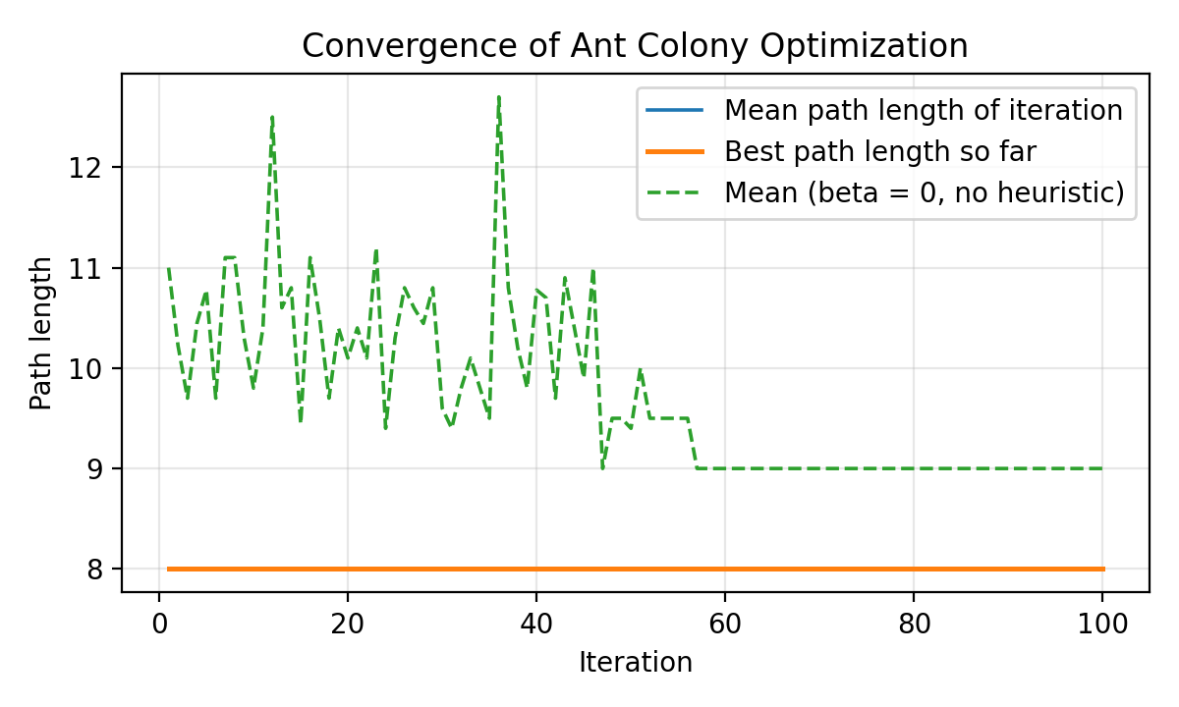
Figure: Convergence of Ant Colony Optimization
- X-axis → Iteration
- Y-axis → Path length
With β = 2 the distance information strongly favours the short edges, so the ants find the shortest path (length 8) in the very first iteration and pheromone then reinforces it. The dashed curve (β = 0, pheromone only) shows the learning effect: the mean path length falls from 11.0 to 9.0 as pheromone builds up on shorter routes.
Parameter Modification
S. No. | Parameter | Original Value | Modified Value | Original Result | Modified Result | Observation
1 | Number of Ants | 10 | 20 | 1 → 2 → 3 → 4 → 5  D = 8 | 1 → 2 → 3 → 4 → 5  D = 8 | More ants explore more paths per iteration; same result
2 | Evaporation Rate | 0.5 | 0.1 | 1 → 2 → 3 → 4 → 5  D = 8 | 1 → 2 → 3 → 4 → 5  D = 8 | Slower evaporation keeps pheromone longer; same result
3 | Distance Importance β | 2 | 0 | 1 → 2 → 3 → 4 → 5  D = 8 | 1 → 2 → 3 → 5  D = 8 | Without heuristic the ants rely on pheromone only; finds an equal-length path (1-2-3-5)
4 | Maximum Iterations | 100 | 10 | 1 → 2 → 3 → 4 → 5  D = 8 | 1 → 2 → 3 → 4 → 5  D = 8 | Solution is found early; 10 iterations suffice here

Conclusion: ACO found a shortest path of length 8. Two paths have this length (1-2-3-4-5 and 1-2-3-5), so either is a correct answer. Results are from a run with random seed 42.
- Problem + Algorithm
Experiment No.: 14
Title: Gram Matrix of a Dataset Using Different Kernels
Aim:
Compute and visualise the Gram matrix of a dataset using different kernel functions and check its properties.
Problem Statement:
For 80 samples of the two-moons dataset (noise 0.08, random seed 1, 40 samples per class), the Gram matrix K[i, j] = k(x_i, x_j) is computed for six kernels: linear x·y, polynomial (x·y + 1)³, RBF exp(−γ‖x − y‖²) with γ = 1 and γ = 10, Laplacian exp(−γ‖x − y‖₁) with γ = 1, and sigmoid tanh(0.5·x·y). A valid kernel gives a symmetric, positive semi-definite (PSD) Gram matrix, i.e. one with no negative eigenvalues. The samples are sorted by class so that class structure appears as blocks in the heatmaps.
Algorithm:
- Generate 80 two-moons samples and sort them by class.
- Compute the Gram matrix for the six kernels with the scikit-learn pairwise kernel functions.
- Check the RBF matrix against a manual computation using ‖x − y‖² = ‖x‖² + ‖y‖² − 2·x·y.
- Check symmetry: K = Kᵀ.
- Compute the smallest eigenvalue of each K; the matrix is PSD if it is at least −10⁻⁸ (a tolerance for rounding error).
- Display each Gram matrix as a heatmap, with white lines separating class 0 from class 1.
- Program
Important sections of the program (q14_gram_matrix.py):
Data and Gram matrices
X, y = make_moons(n_samples=80, noise=0.08, random_state=1)
order = np.argsort(y)
X, y = X[order], y[order] # sorted by class

kernels = {
"Linear: x·y": linear_kernel(X),
"Polynomial (deg=3)": polynomial_kernel(X, degree=3,
gamma=1, coef0=1),
"RBF (gamma=1)": rbf_kernel(X, gamma=1.0),
"RBF (gamma=10)": rbf_kernel(X, gamma=10.0),
"Laplacian (gamma=1)": laplacian_kernel(X, gamma=1.0),
"Sigmoid (tanh)": sigmoid_kernel(X, gamma=0.5, coef0=0),
}

Core algorithm (manual check and properties)
sq = (np.sum(X**2, 1)[:, None] + np.sum(X**2, 1)[None, :]
- 2 * X @ X.T)
assert np.allclose(np.exp(-1.0 * sq), kernels["RBF (gamma=1)"])

for name, K in kernels.items():
min_eig = np.linalg.eigvalsh(K).min()
symmetric = np.allclose(K, K.T)
valid = min_eig > -1e-8 # PSD check

The complete executable program can be maintained digitally through Github.
- Output + Analysis
Objective Function:
Compute K[i, j] = k(x_i, x_j) for each kernel and test whether K is symmetric and positive semi-definite.
Dataset: Two moons, 80 samples (40 per class), noise = 0.08
Kernels: Linear, polynomial (degree 3), RBF (γ = 1, 10), Laplacian (γ = 1), sigmoid (γ = 0.5)
PSD Tolerance: −10⁻⁸ on the smallest eigenvalue
Random Seed: 1
Program Execution
Final Optimal Solution:
Five of the six kernels give a valid (PSD) Gram matrix; the sigmoid kernel does not
Smallest Eigenvalue of the Sigmoid Matrix:
−2.2389
Execution Status: Successfully Executed
Manual RBF computation matches rbf_kernel (assert passed)
Linear: x·y : Symmetric = True, Min eigenvalue = -0.0000, Valid (PSD) = True
Polynomial (deg=3) : Symmetric = True, Min eigenvalue = -0.0000, Valid (PSD) = True
RBF (gamma=1) : Symmetric = True, Min eigenvalue = 0.0000, Valid (PSD) = True
RBF (gamma=10) : Symmetric = True, Min eigenvalue = 0.0000, Valid (PSD) = True
Laplacian (gamma=1) : Symmetric = True, Min eigenvalue = 0.0077, Valid (PSD) = True
Sigmoid (tanh) : Symmetric = True, Min eigenvalue = -2.2389, Valid (PSD) = False

Gram Matrix Heatmaps
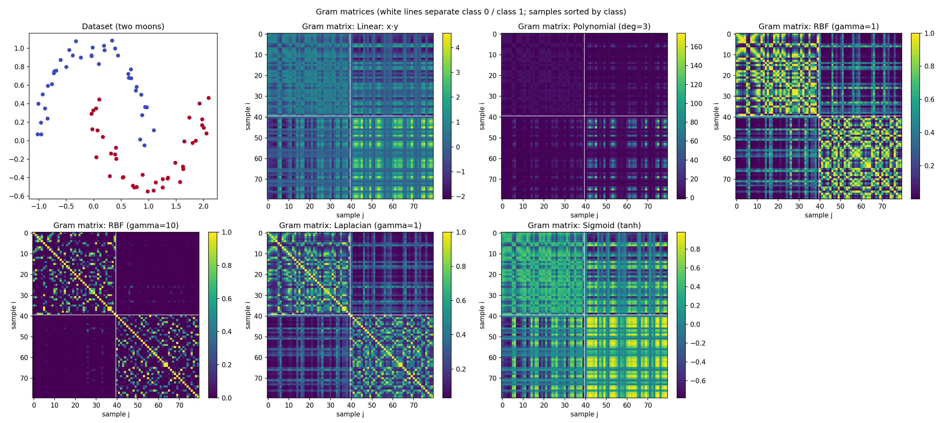
Figure: Gram Matrices of the Two-Moons Data for Different Kernels
- X-axis → Sample j
- Y-axis → Sample i (colour = k(x_i, x_j); white lines separate class 0 and class 1)
The samples are sorted by class, so a kernel that captures the class structure shows two bright diagonal blocks (class 0 and class 1) and dark off-diagonal blocks. This is clearest for RBF with γ = 10, where the matrix is almost zero between the classes and bright only close to the diagonal, followed by RBF with γ = 1 and the Laplacian kernel. The linear, polynomial and sigmoid matrices show a striped pattern instead of blocks, because their values depend on the length and direction of the vectors (the polynomial values reach about 170) rather than on the distance between samples. The sigmoid kernel also contains negative values and is the only matrix that is not positive semi-definite.
Parameter Modification
S. No. | Parameter | Original Value | Modified Value | Original Result | Modified Result | Observation
1 | RBF γ | 1 | 10 | Min eigenvalue ≈ 0 (PSD)  Mean off-diagonal = 0.3405 | Min eigenvalue ≈ 0 (PSD)  Mean off-diagonal = 0.0671 | Larger γ makes similarity more local, so K moves towards the identity matrix
2 | RBF γ | 1 | 0.1 | Min eigenvalue ≈ 0 (PSD)  Mean off-diagonal = 0.3405 | Min eigenvalue ≈ 0 (PSD)  Mean off-diagonal = 0.8313 | Smaller γ makes almost all points look similar, so K approaches the all-ones matrix
3 | Polynomial degree | 3 | 2 | Min eigenvalue ≈ 0 (PSD)  Mean off-diagonal = 6.6904 | Min eigenvalue ≈ 0 (PSD)  Mean off-diagonal = 2.6732 | Lower degree gives smaller kernel values and the matrix stays PSD
4 | Sigmoid γ | 0.5 | 0.1 | Min eigenvalue = −2.2389  Mean off-diagonal = 0.1124 | Min eigenvalue = −0.0489  Mean off-diagonal = 0.0289 | The violation is much smaller but the matrix is still not PSD, so the sigmoid kernel is not valid here

Conclusion: The linear, polynomial, RBF and Laplacian Gram matrices are symmetric and positive semi-definite, so they are valid kernels. The sigmoid kernel (γ = 0.5, coef0 = 0) is not PSD (smallest eigenvalue −2.2389), so it does not correspond to an inner product in a feature space for these parameters. The RBF parameter γ controls how local the similarity is, and the manual RBF computation matches the library result. Results are from a run with random seed 1.

